Proposal

Client:

Tourism New Zealand

Tourism New Zealand works with the tourism industry to positively promote New Zealand internationally. They have a new campaign aimed at visitors who are staying for short periods, arranging their own transport.

Problem:

Tourism New Zealand have a new campaign aimed at visitors who are staying for short periods, to be able to arrange their own transport.

Desired product:

To achieve this Tourism New Zealand has asked for a one page web application that allows the users to input information, validate it and then provide transport options and calculate cost based on

the information provided by the user.

Requirements

* User to input information
* Validate the information
* Display data in a appropriate form

Due Date

14th December 2017

Use case diagram

Choose start destination

Select vehicle

Select # of passengers and days traveling

Visit Site

Choose activity destination

Contact TNZ to book

Defined deliverables

* Design for use on a tablet.
* Use a plugin that displays images for the activity locations.
* Use modals to show the vehicle data.

How these were achieved:

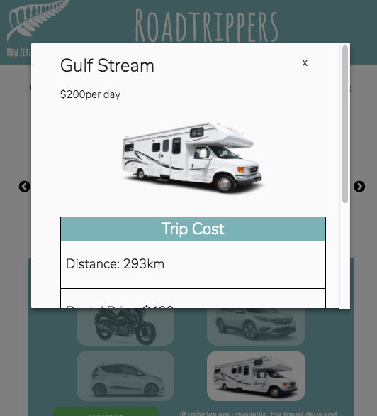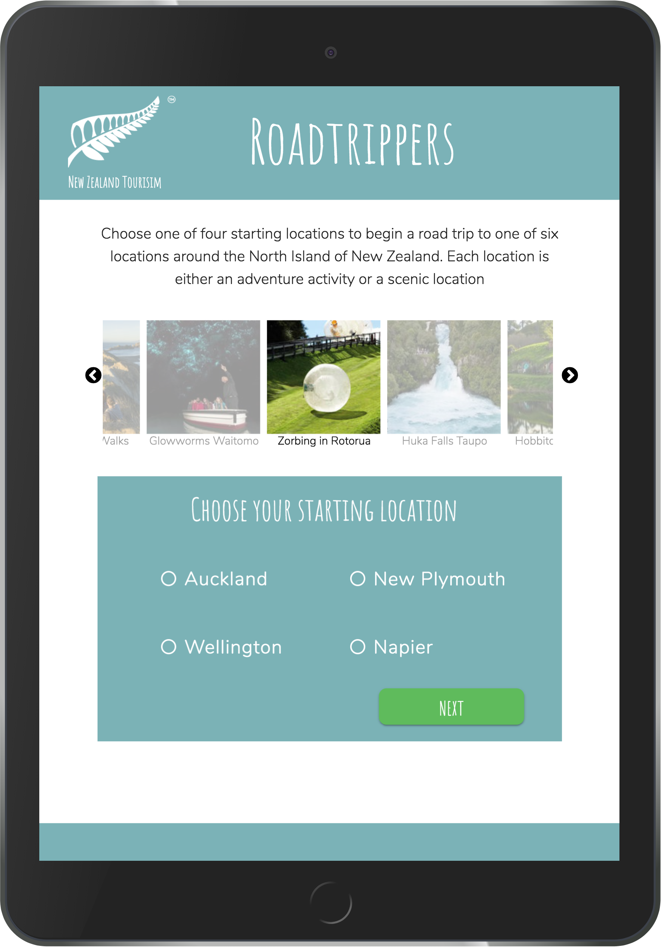

Modals used for the display of vehicle and its data

The design was made for a tablet

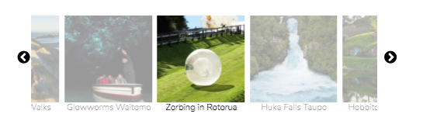

Slick was used for the display of the images in a carousel

Timeline for deliverables

|  |  |  |
| --- | --- | --- |
| Deliverable | Deadline | Outcome |
| Plugin for images | Find plugin 27th Nov  Design and implement 6th Dec | Achieved  Achieved |
| Design for tablet | Design and create prototype 29th Nov  Implement design with HTML and CSS 6th Dec | Late-1st dec  Achieved |
| Modals for data | Design and implement 10th Dec | Achieved |

JavaScript Style Guide

Naming conventions

* All names start with a letter
* camelCase is used for names when required
* Avoid single letter names, be descriptive with naming

Spaces around operators

* Always put spaces around operators and after commas

e.g. var x = y + z;

Code indentation

* Tabs will be used for indenting

Statement Rules

* Always end a simple statement with a semicolon

e.g. var values = [1, 2, 4, 6];

* Complex statements do not end with semicolon and closing bracket is on a new line

Objects

* Opening bracket on the same line as object name
* Use quotes around string values
* No comma after the last property
* Closing bracket on a new line
* End object with a semicolon

Strings

* Use single quotes for strings

e.g. var name = ‘John’

|  |  |  |
| --- | --- | --- |
| Deadline | | Result |
| Research UI and Javascript Libraries  27th Nov | | Achieved |
| Research and create a Js styleguide  27th Nov | | Achieved |
| Research colours and fonts and design concept  28th Nov | | Late – 1st December, due to not being able to do anything over that weekend I had to add a few extra days to finish this |
| Create prototype  29th Nov | | Late- 1st December, due to being later on the design research this pushed back the creationg of the protype |
| Set up documentation  Dec 1st | | Achieved |
| Start HTML and CSS  Dec 1st | | Achieved |
| Finish HTML and CSS  Dec 6th | | Achieved |
| Plan out JS user flows  Dec 5th | Early- dec 4th as this was a fairly simple flow I was able to do this while I was writing the HTML | |
| Start writing up Js  Dec 6th | Achieved | |
| Finish writing js and debug  12th Dec | Early- 10th Dec | |
| Finish documentation  13th Dec | Early-12th Dec | |

Timeline

Analysis of how well adhered to timeline

From the table above you can see that through the majority of the project I was able to stick to the deadlines. The two instances that I was late on the deadline was due to the fact that as a student I also have to work outside of class and so I had work all that weekend and was unable to do anything. This also meant that the next deadline was pushed as well. However I was able to make up time and get back on track.

In the future I would add extra time to allow for things such as work and to still be able to keep to the deadlines.

Production tools

Github

<https://github.com/Kelseys1993/foundation-summative>

Used to manage and store files throughout production

Sublime text

Sublime text 2 was used as the code editor for the entirety of the project.

Koala

Koala was initially used for the syncing of sass and to check for errors in CSS. When gulp was inputted it was no longer used as gulp had that capability also.

Gulp

Gulp was used to check the javascript code for errors and provided a linting tool. It was effective and also had the added benefit of having a local sever which reloaded the browser on save therefore eliminating the need to refresh the page after every new addition.

Asana

Asana was used to initially set up the main tasks and to set deadlines for when each task was to be finished